**LAB REPORT**

**OF**

**SOFTWARE PROJECT MANAGEMENT**

**Submitted by**

Sajal Shakya

**Exam Roll No.:**8793/18

**Nagarjuna College of Information Technology**

**Submitted to**

**Faculty of Management, Tribhuvan University** in partial fulfillment of the requirements for the degree of **Bachelor of Information Management**

**2023**

**Table of Contents**

Lab 1: Getting Familiar with Microsoft Project 3

1.1 Creating a Project File 3

1.2 Task 4

1.3 Resource 4

1.4 Report 4

1.5 Project 5

1.6 View 5

1.7 Format 6

Lab 2: Creating Gantt Chart in Microsoft Project 8

2.1 Inserting Task in MS Project 8

2.2 Creating Task Hierarchy 9

2.3 Defining Duration, Start and Finish Date 10

Lab 3: Adding Predecessors, Priority, Lag and Managing Dependencies 11

3.1 Adding Predecessors 11

3.2 Adding Priorities 11

3.3 Managing Dependencies and Defining Lag 12

Lab 4: Allocating Resources to Task 14

4.1 Creating Resource Pool 14

Lab 5: Defining and Adjusting Work Time 16

5.1 Creating a new Calendar 16

5.2 Changing Work Time Defaults 17

5.3 Adding Exceptions and Holidays to the Calendar 17

Lab 6: Inserting Progress of each Tasks 19

Lab 7: Critical Task, Slack and Late Tasks 20

Lab 8: Generating Report 21

Lab 9: Critical Path Numerical 22

Lab 10: Git and GitHub 25

# Lab 1: Getting Familiar with Microsoft Project

Microsoft Project is project management software program that allows users to plan, manage, and track projects, resources and budgets.

Here, we will see the different features of Microsoft Project.

## 1.1 Creating a Project File

At first, install and open Microsoft Project to create a project. This is the first page we see on our screen when Project is opened.

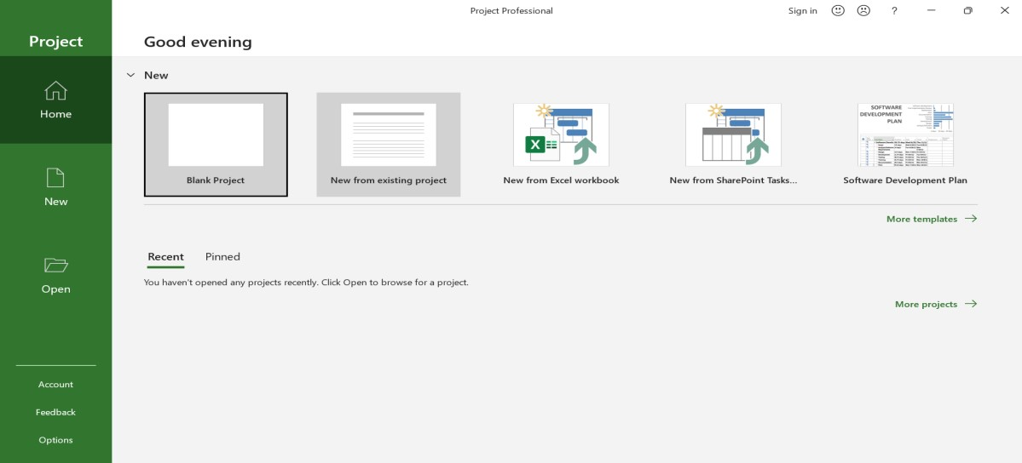

Then we click on Blank Project and we get to the following screen:

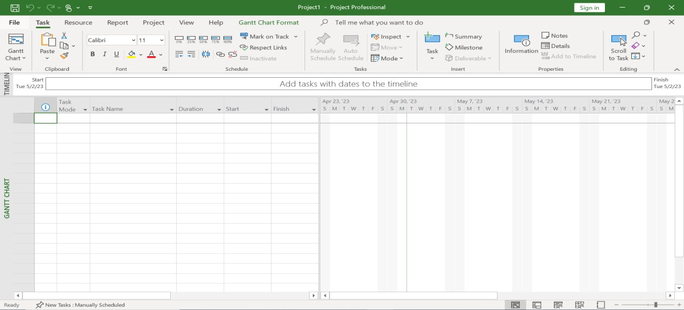

Here in the above screen, we can see multiple interfaces in Menu Bar like: File, Task, Resource, Report, Project, View and Format.

## 1.2 Task

Task is the first menu. It includes every feature that enables us to manage the work that has to be done on a project. These include:

* Task Linkage
* Task Indentation
* Task Completion
* Task Schedule, etc.

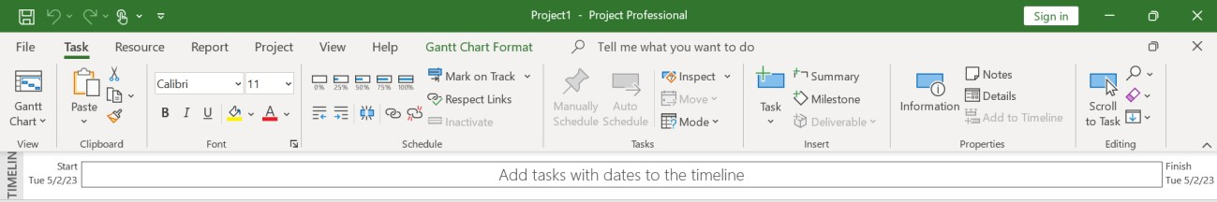

## 1.3 Resource

Resource is the second menu item. It enables us to manage the resources that are already on hand and those that the project will need. Among them are the following:

* Adding Resources
* Assigning resources
* Managing resource levels
* Managing resource pools

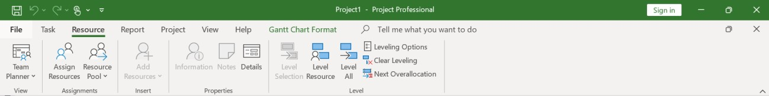

## 1.4 Report

When a report needs to be prepared for managerial purposes, this menu is used. We are able to create a variety of reports using the Microsoft Project. Some report-related characteristics are:

* Dashboards: a summary of the chosen category, including Cost, Project, Task, etc.
* Resources
* Costs: include earned value, task cost, resource cost, and cash flows.
* In Progress: milestones, critical tasks, late tasks, and slipping tasks
* Visual Reports: visual depiction of the project
* Custom: report with a format that is specified by the user.

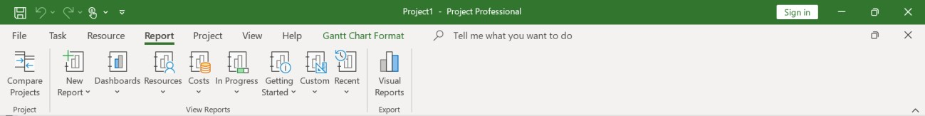

## 1.5 Project

With the help of this menu, you can further customize your project by adding new requirements, modifying the task or resource requirements, or adding constraints or variables. In a similar vein, it also makes work breakdown and time management easier. Its most popular choices include:

* Adjust working hours
* Set Baseline
* Project links between each other and custom fields

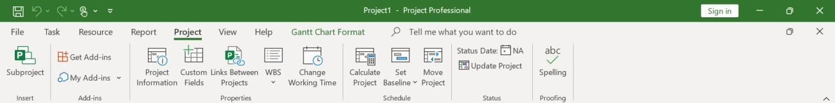

## 1.6 View

The view menu allows us to select how we wish to display the various project components, including tasks, resources, data, etc. Additionally, it enables us to alter the software's view format.

This menu's features include:

* Resource Views
* Task Views
* Data Filter
* Spilt View

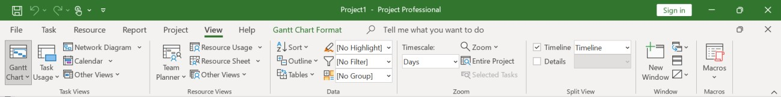

## 1.7 Format

We can alter the formatting specifics of the sheet we are working on, using the Format menu. The format menu varies along with our choice of view just as the sheet we are working on may alter depending on our needs. The format of the mentioned figure is based on Gantt Chart Tools:

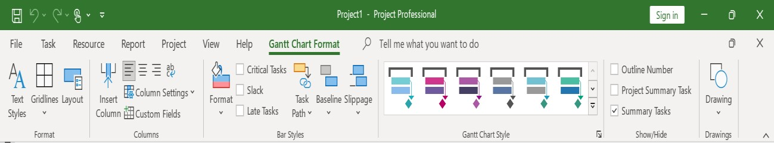

If we select another viewpoint i.e., Calendar, it changes to the following:

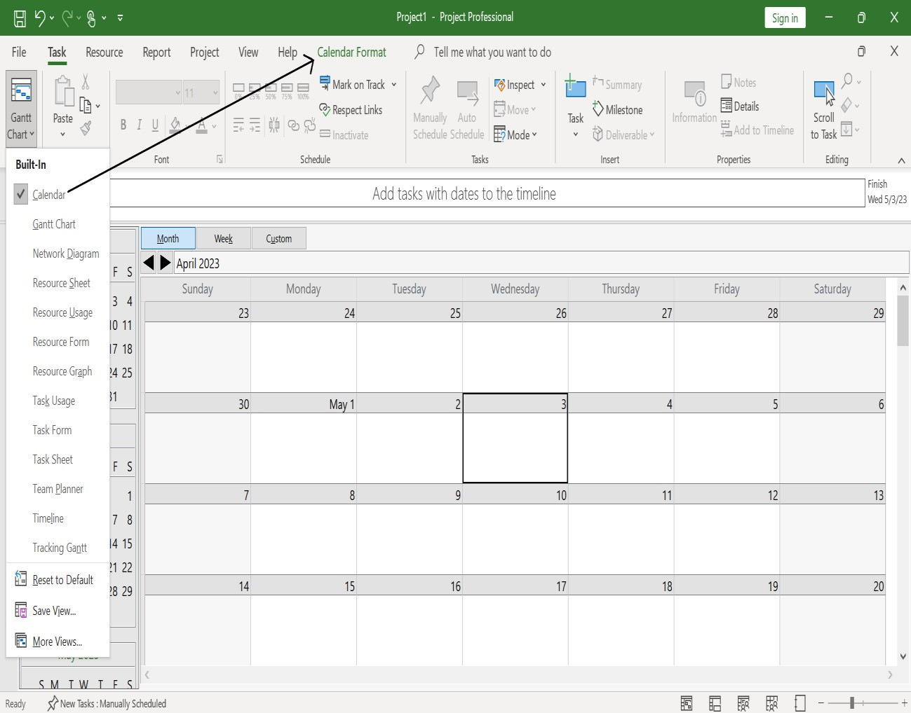

If we select another viewpoint i.e., Network Diagram, it changes to the following:

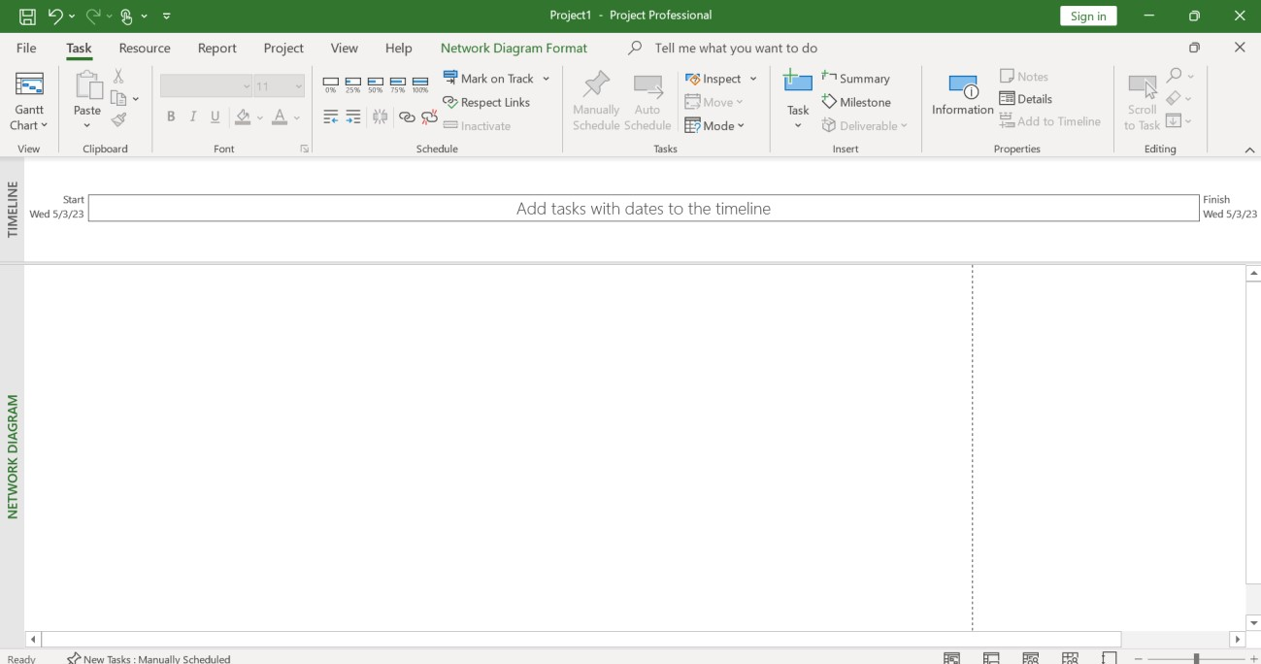

# Lab 2: Creating Gantt Chart in Microsoft Project

### 2.1 Inserting Task in MS Project

Step 1: Open Project and click on a new Blank Project

Step 2: Select Gantt Chart from View option

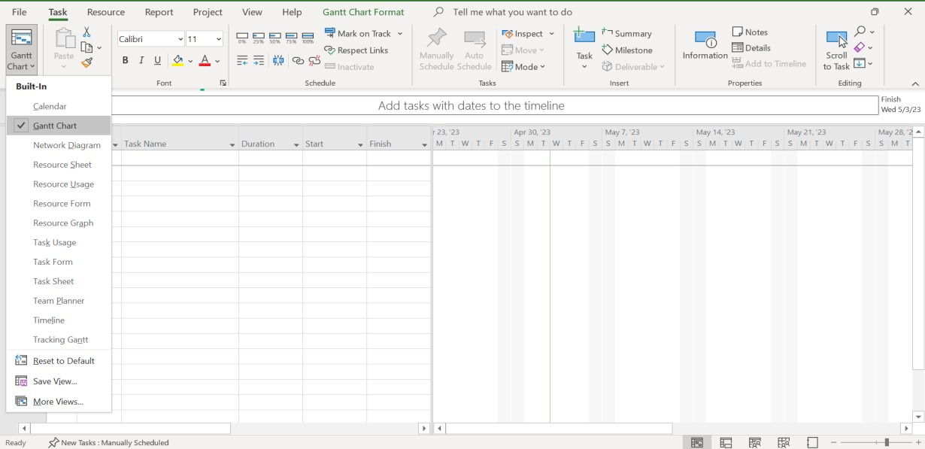

Step 3: Add the tasks to the sheet's Task Name field. Either click in the text area and type each task's name, or copy and paste the tasks from another list. In order to keep the project organized, it is advised to list the tasks in progressive order.

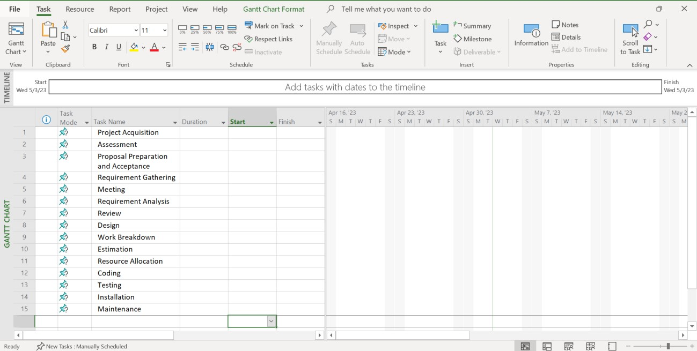

### 2.2 Creating Task Hierarchy

After the tasks have been entered in the correct order, we can use indentation to add hierarchy to the tasks. Using the icons in the Schedule area of the Task menu bar, we may either indent or outdent a task.

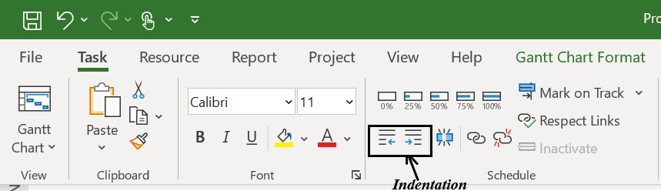

No tasks can be outdented because our task list is in its normal state. By indenting the desired tasks, we can make subtasks. A task becomes a subtask of the task above it when we indent it. A task's hierarchy gets lower the more it is indented.

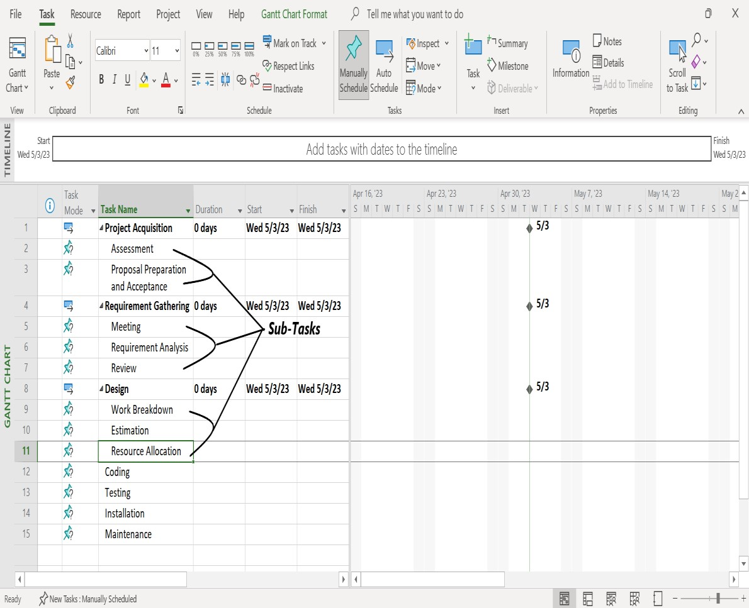

### 2.3 Defining Duration, Start and Finish Date

Step 1: Click on Start column, then either enter date manually or select one from the Calendar.

Step2: Click on Finish column, then either enter date manually or select one from the Calendar.

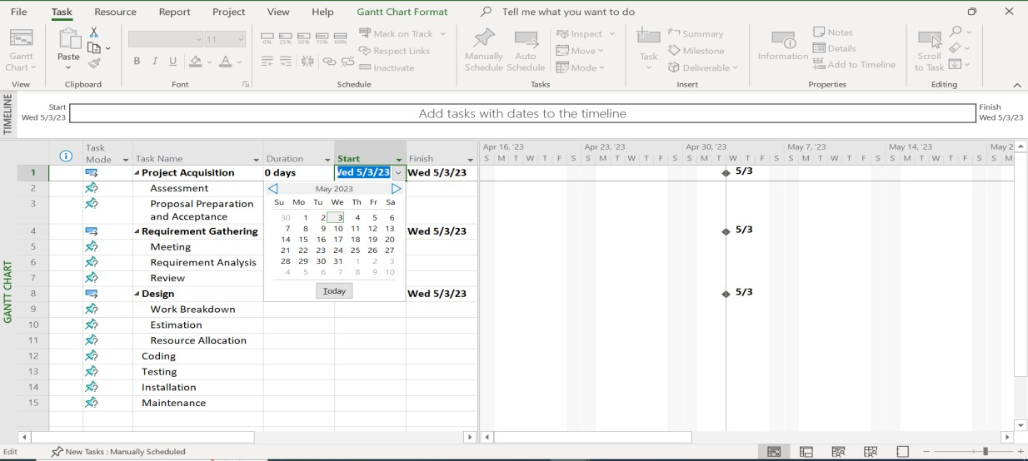

After selecting dates, duration will be automatically calculated based on work-time provided.

Another way of entering start and finish dates, is to enter one of them and enter the estimated duration required to complete task and the corresponding date will be automatically updated.

The Gantt Chart will be constructed on the right side, as shown in the image below, when starting and finishing dates have been assigned to all of the tasks.

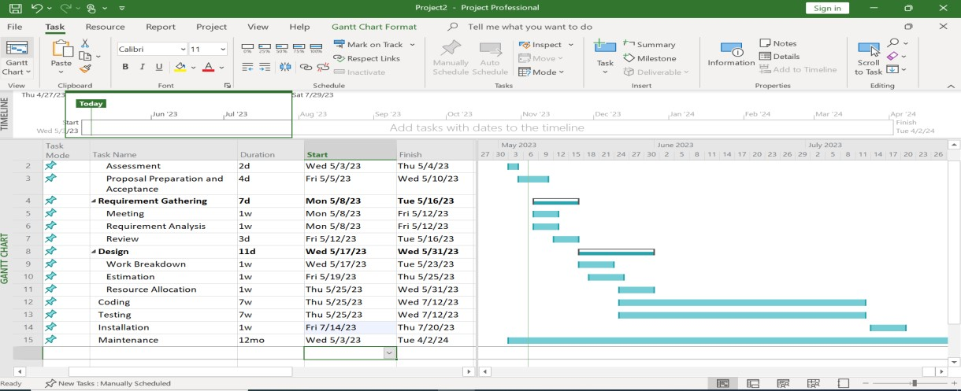

# Lab 3: Adding Predecessors, Priority, Lag and Managing Dependencies

#### 3.1 Adding Predecessors

By simply adding the task number to the predecessor's column, we can add predecessors to tasks. The predecessor field for the dependent task is filled up with the task number of the preceding task or tasks. By doing this, the tasks now have a straightforward finish-to-start dependency. This linkage can also be seen in the Gantt chart.

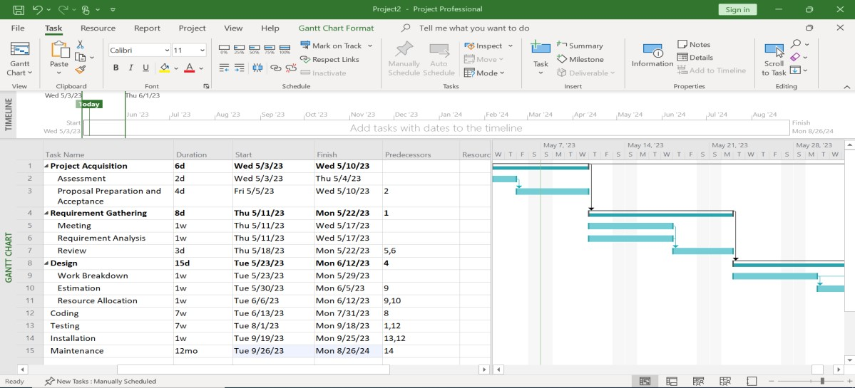

#### 3.2 Adding Priorities

To add priority, we have to add new column in the sheet. The Add New Column can be found at the end of the column in the sheet.

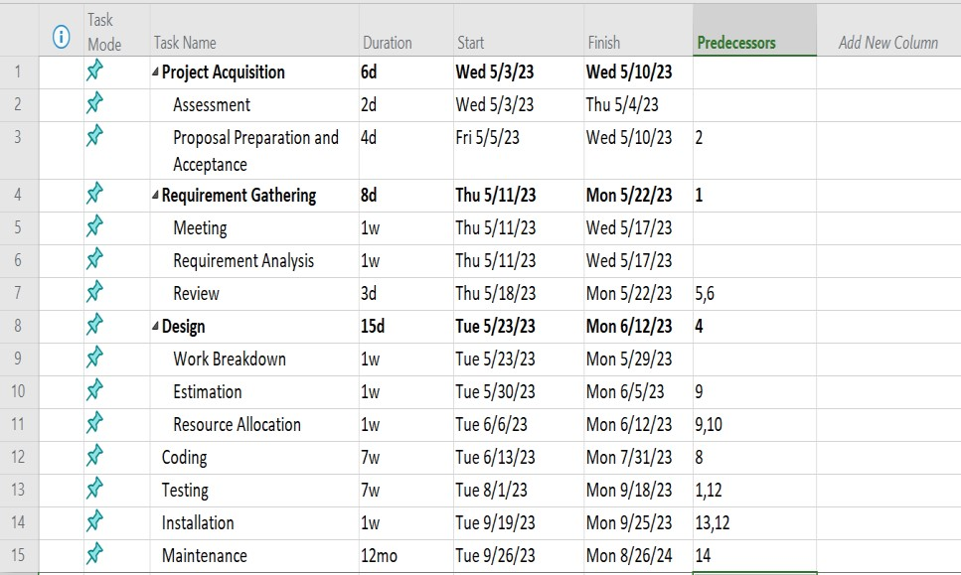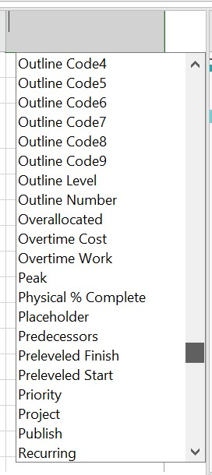

**Add New Column**

**Priority**

We select the Priority option from a list of possibilities after selecting Add New Column in order to create a new column for Priority.

We can assign the desired priority points to each task as necessary once the priority column has been formed.

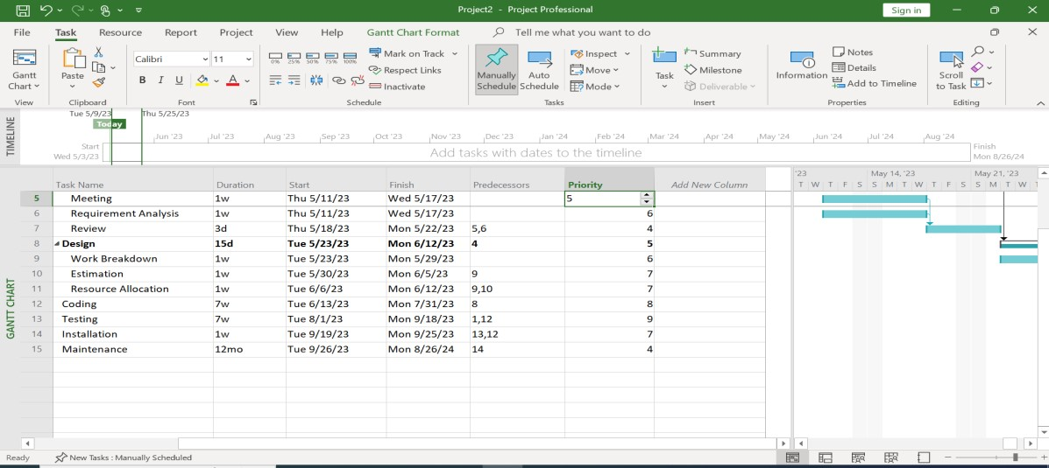

Adding priority does not bring any changes to the Gantt chart.

#### 3.3 Managing Dependencies and Defining Lag

When we double click on the task, we can see more detailed control on the dependencies and other aspects of the task. It will open a Task Information menu containing tabs like General, Predecessors, Resources, and so on.

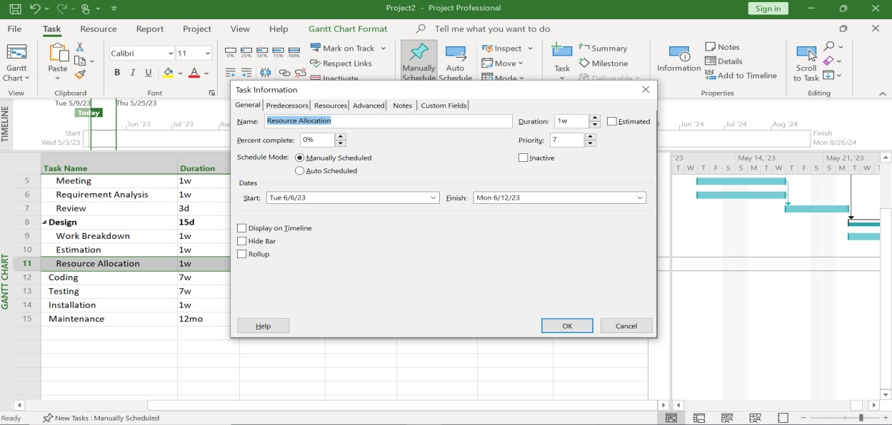

Select the Predecessors tab to control the different sorts of dependencies and specify lag. It will provide us a document with a list of predecessors, their types, and their lags on it.

From this window, we can choose the kind of dependency and add the desired amount of lag.

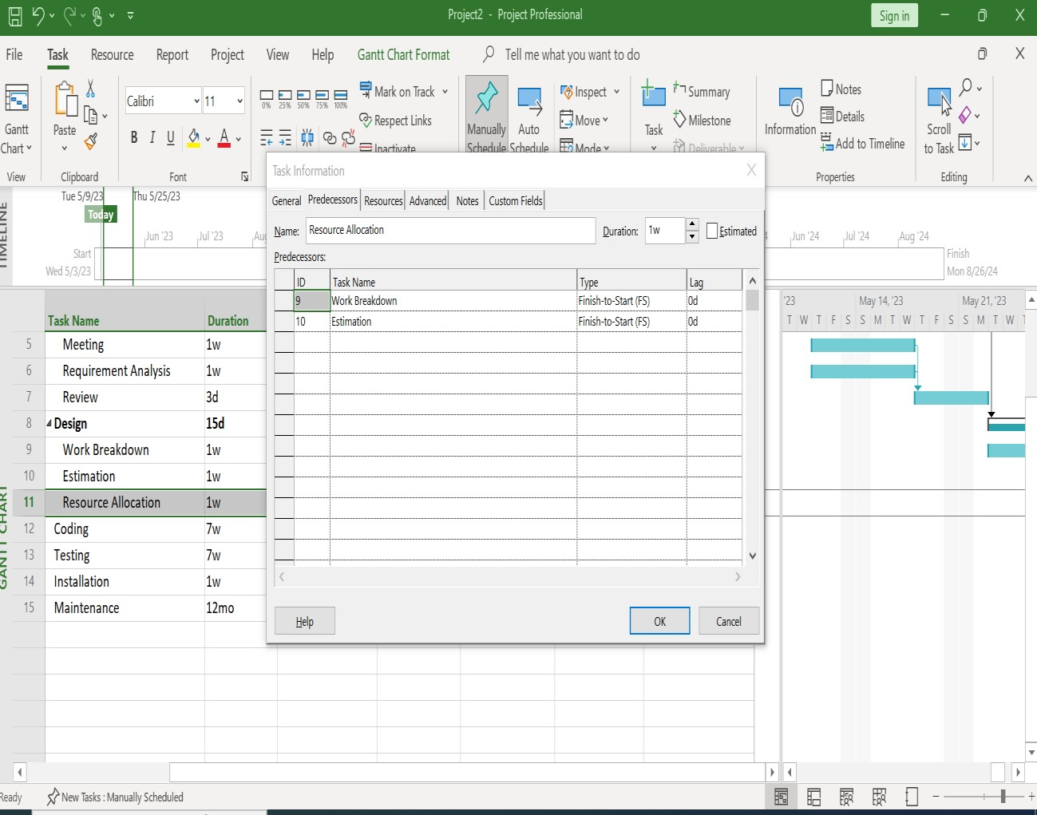

# Lab 4: Allocating Resources to Task

###### 4.1 Creating Resource Pool

We must first access the resource sheet in order to construct a resource pool. Click on the view options or Gantt chart in the top left corner of the menu ribbon to access the Resource Sheet. When you do this, a drop-down menu with various view options will appear. Select Resource Sheet.

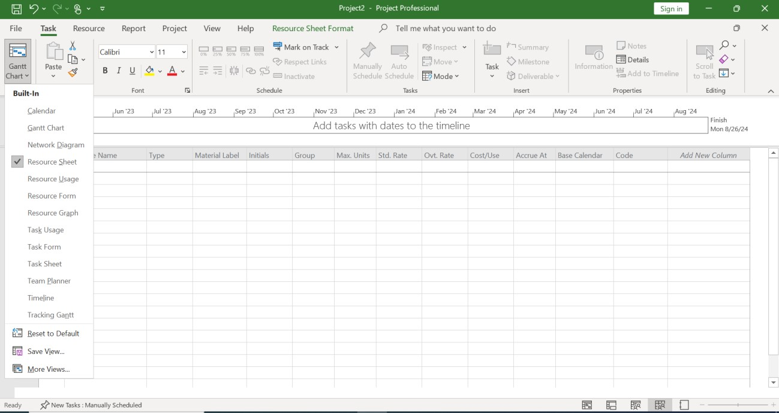

**1:**

**Click**

**2:**

**Select**

After selecting Resource Sheet, we can now add resources through the sheet as follows:

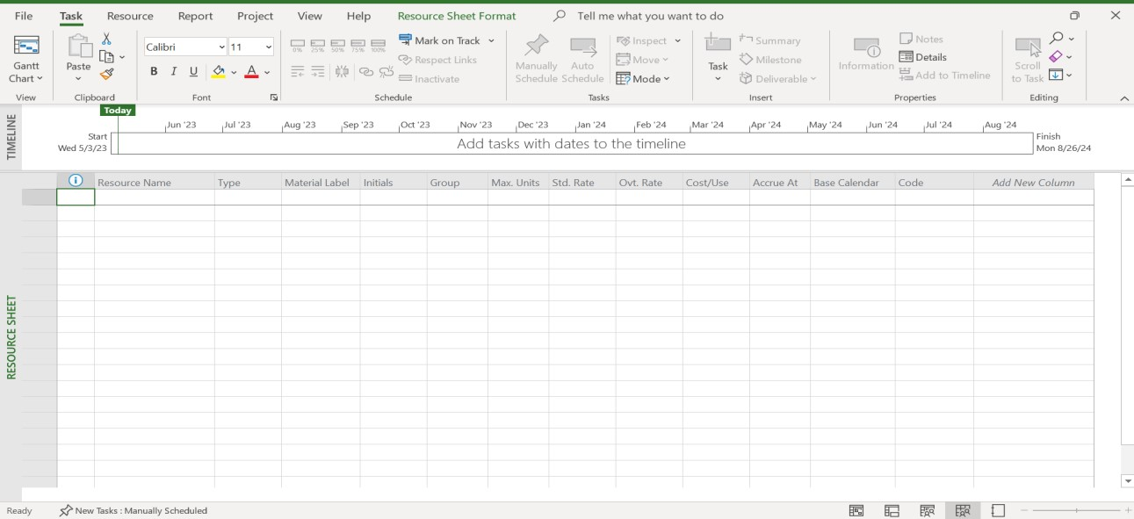

We now add the resources by entering the necessary details related to the resource. Employees were utilized as resources for this lab activity, and after entering the necessary data, it appears as follows:

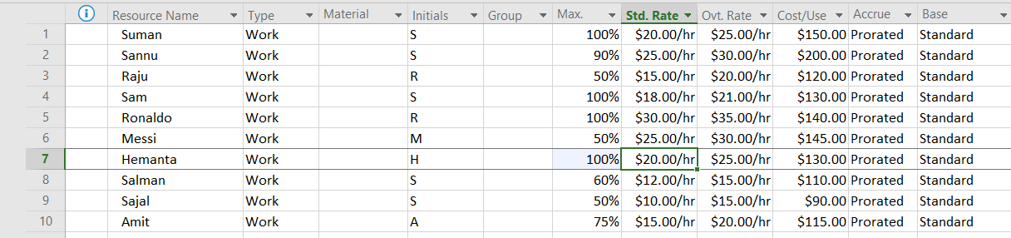

The sheet includes a list of the resources that will be available for the project, along with information on each one.

We now select the Gantt chart option from the menu under View and enter the resource names we want for each task in the Resource Names column. Several resources can be devoted to a single task. Following the resource allocation, our sheets appear as follows:

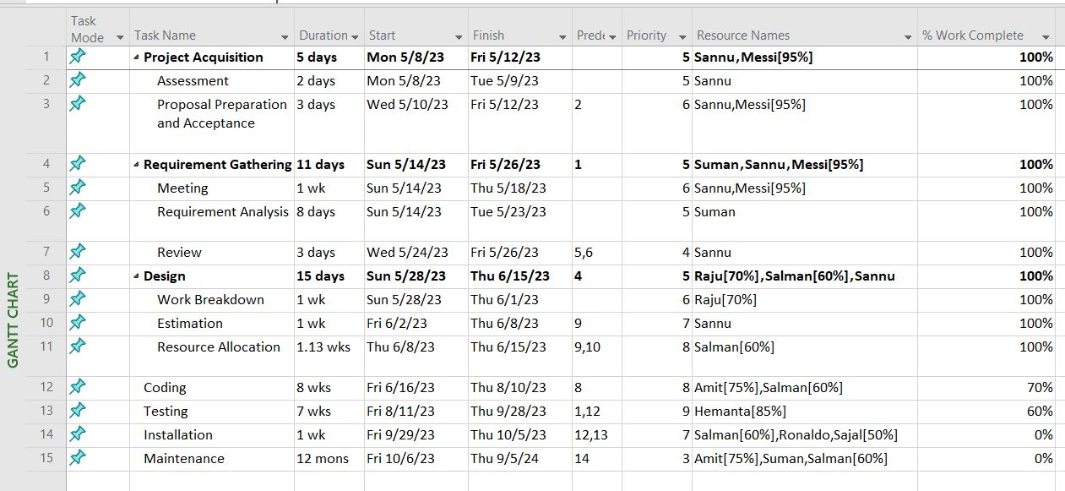

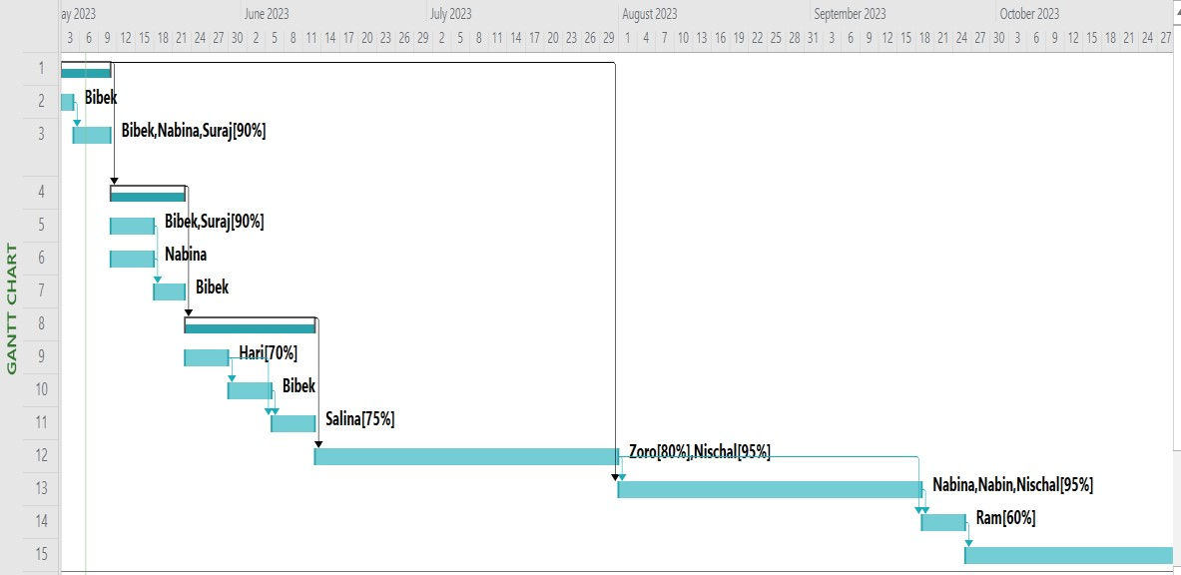

# Lab 5: Defining and Adjusting Work Time

We navigate to the Project option on the menu bar to make any modifications related to work time.

After that, we choose Change Working Time. This brings up a dialog box with the title "Change Working Time," where we can manage, adjust, or modify anything related to the project's work time.

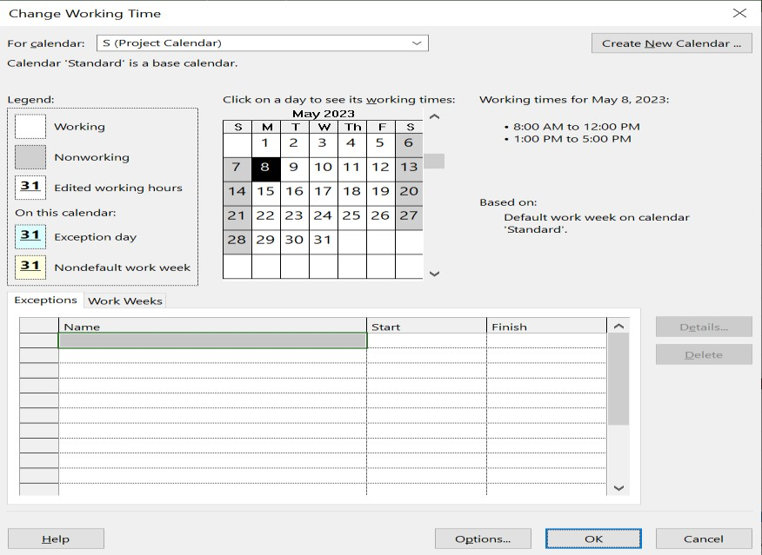

##### 5.1 Creating a new Calendar

We can change the time on the standard calendar or make a new calendar using the Change Working Time dialog box.

Click on Create New Calendar in the top right corner to start a new calendar. A dialog box will appear asking us how we want to make the new calendar. By doing this, a new dialog box will appear, allowing us to modify the calendar defaults.

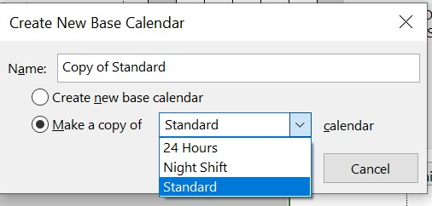

We can either create a completely new base calendar or create a copy of already available Standard, Night Shift, or 24 Hours calendar.

##### 5.2 Changing Work Time Defaults

A default value is specified for some schedule components, including the beginning of the day, the start and end times of the workday, the number of hours in a day, etc. We can change the default values according to our preferences.

In the Change Working Time dialog box, select the Options button in the bottom right corner to customize the defaults.

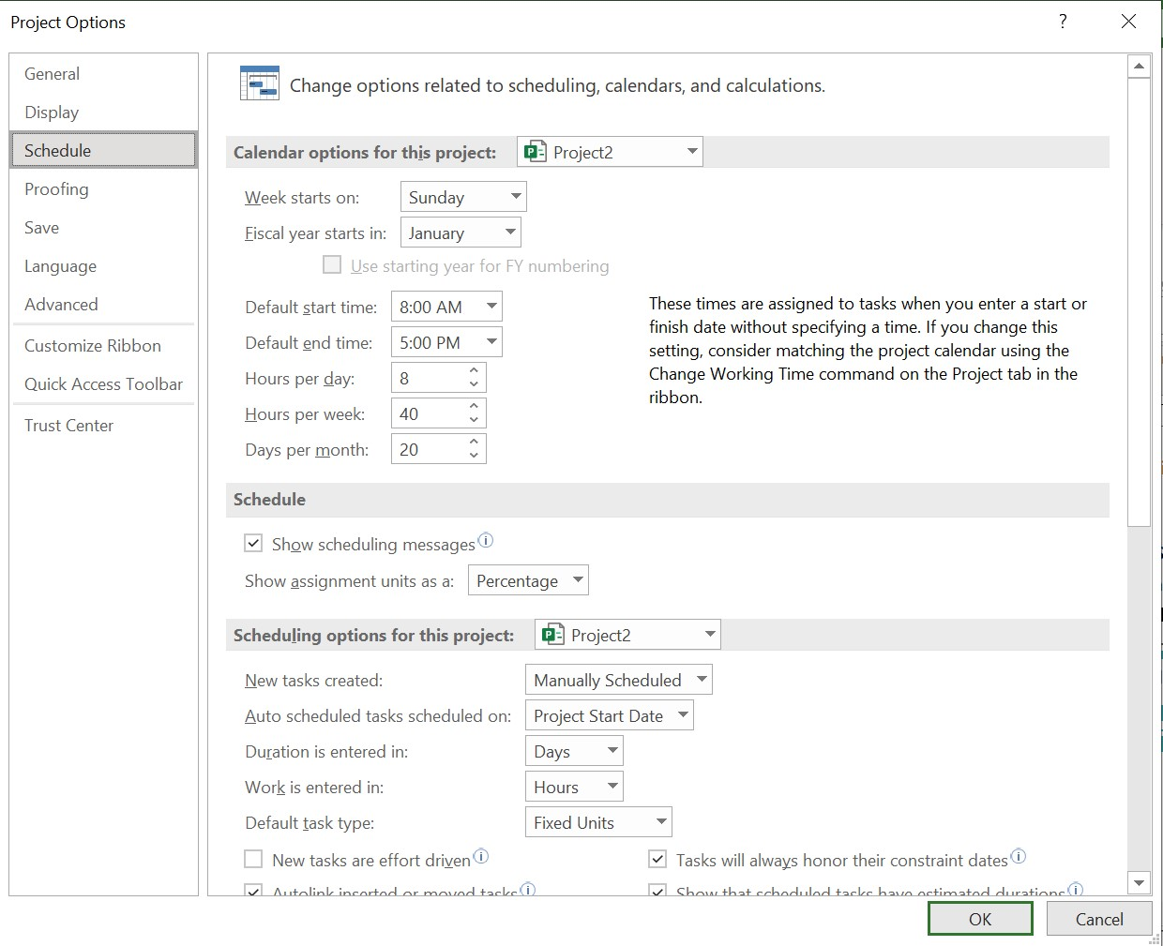

##### 5.3 Adding Exceptions and Holidays to the Calendar

Simply enter the exceptions in the exception sheet of the Change Working Time dialog box to add any holidays or exceptions to the calendar. We must include the name of the exception as well as its start and end dates.

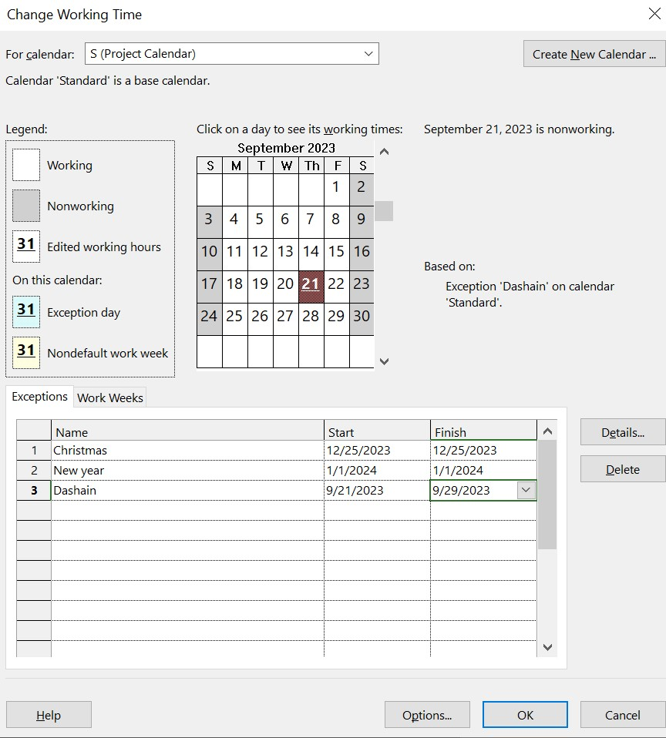

We can also add extra information to the exceptions, such half-day work, a pattern of recurrence or a range of recurrence. Simply double-clicking the exception's name or the Details button on the right side will accomplish this.

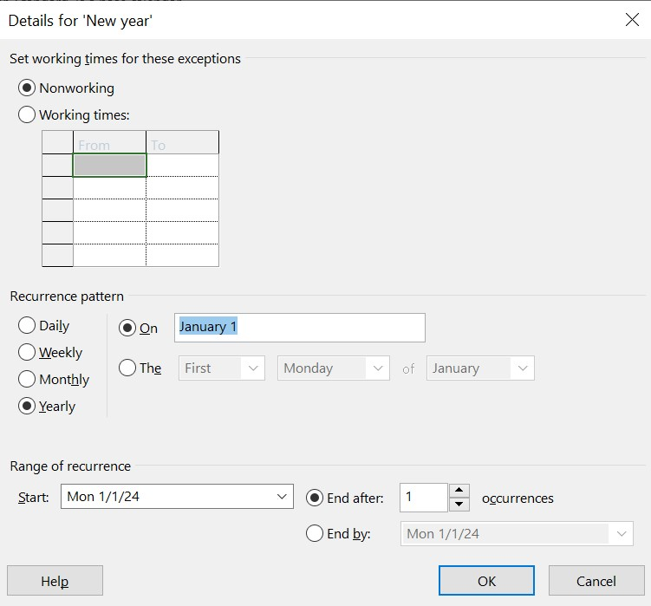

# Lab 6: Inserting Progress of each Tasks

To add progress details for tasks we add a new column. This process is similar to adding priority.

Click on Add New Column in the Gantt chart view then select ‘% Work Complete’. In this field we can add the percentage of work completed of each task.

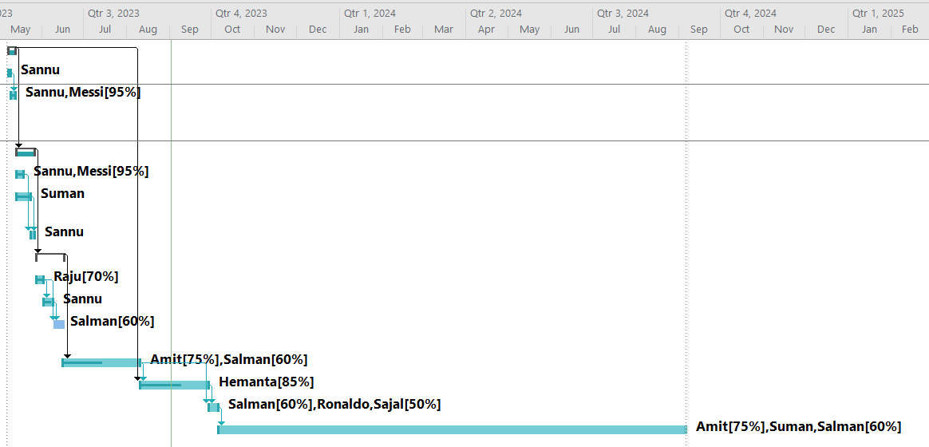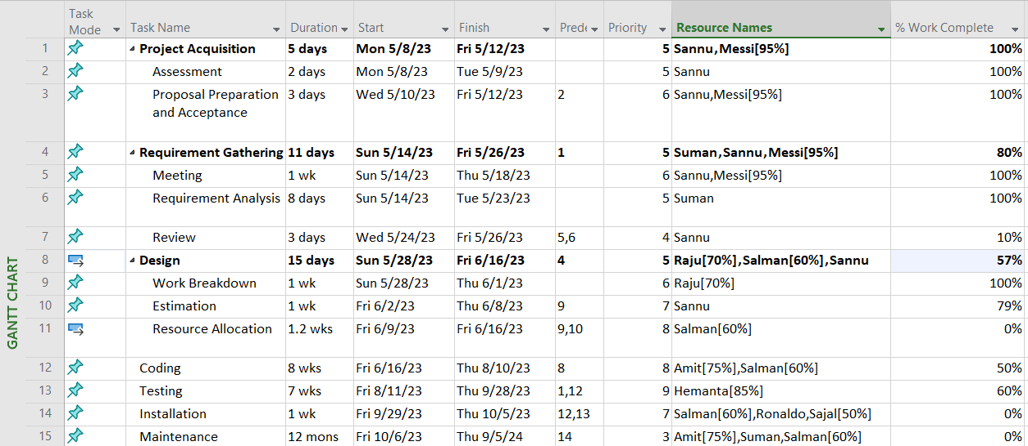

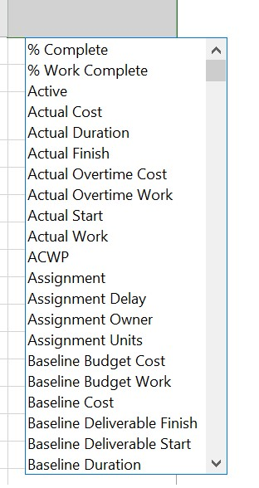

**Select % Work**

**Complete**

In the chart, the dark line inside the Task Bar represents Task Progress.

# Lab 7: Critical Task, Slack and Late Tasks

In Microsoft Project, finding critical task, slack task, and late task is simple. To do this, select the Gantt Chart Format menu, then under Bar Styles, check the appropriate box from among critical task, slack, and late task.

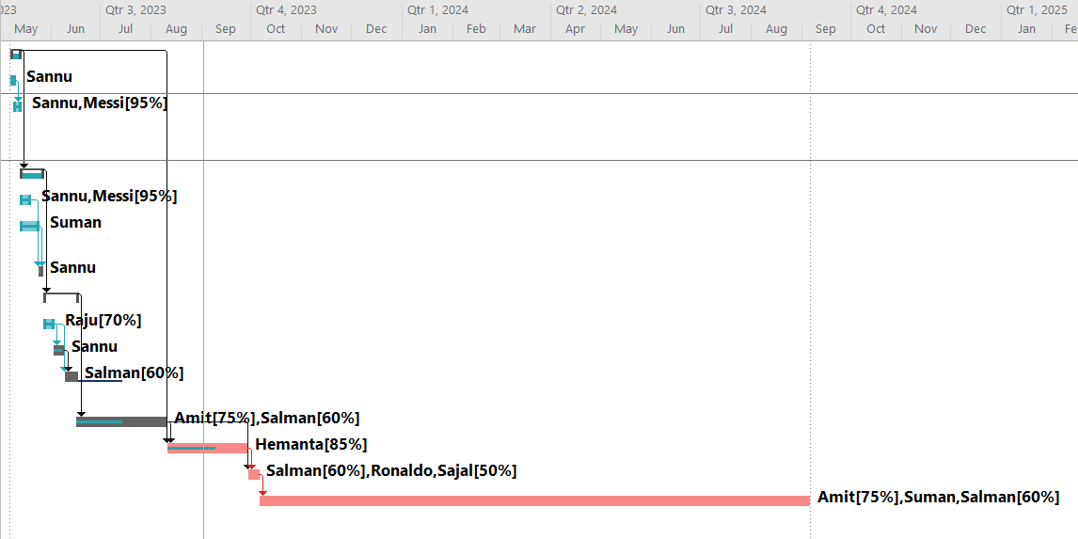

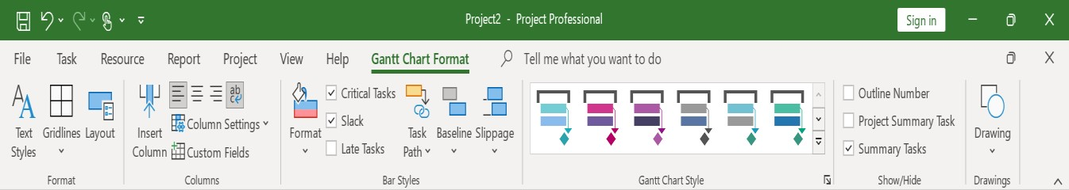

**Tick on desired option**

Tasks that cannot be delayed without affecting the project finish date are the critical tasks. Here, Critical Task is represented by pink color inside Task Bar.

If a baseline exists and the project/task finish date is the same as the baseline finish date, then the project/task is considered late if it is not completed and it was due before today's date. Here, Late Task is represented by grey color inside Task Bar.

Slack is the amount of time a task can slip before it bumps into another task. Here, Slack is represented by straight line.

# Lab 8: Generating Report

To prepare report, we go to Report menu then select the desired report. The report can be an overview report or related to resources, costs or progress.

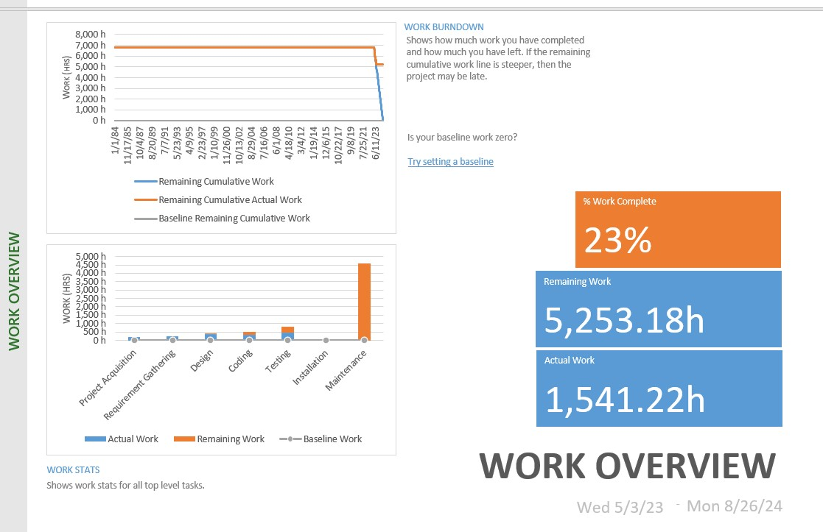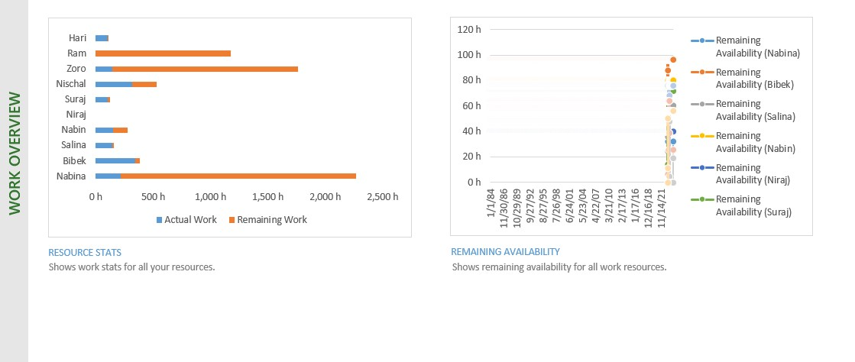

Here is an example of report (select Dashboard and click on Work Overview).

# Lab 9: Critical Path Numerical

Here we will be finding critical path using MS Project.

**Numerical 1:**

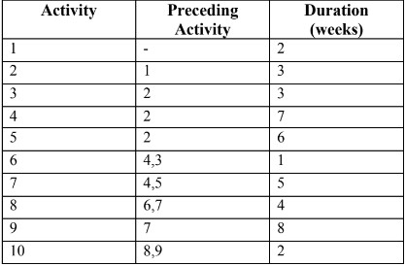

To find Critical Path, we need to enter the given details on Project:

For start and finish, we can select a random start date and let project auto schedule the remaining ones.

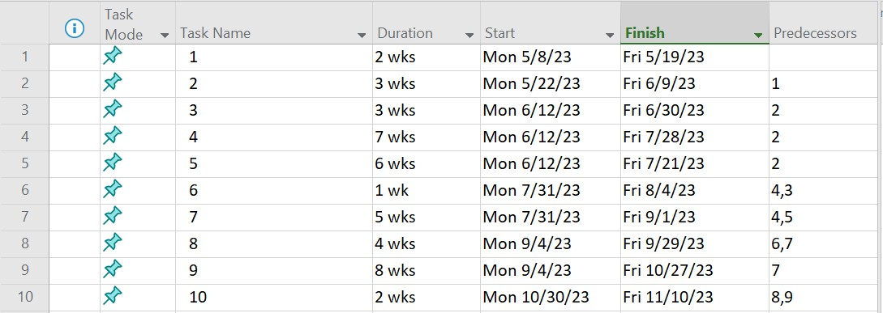

After entering above details, we change the view from Gantt Chart to Network Diagram.

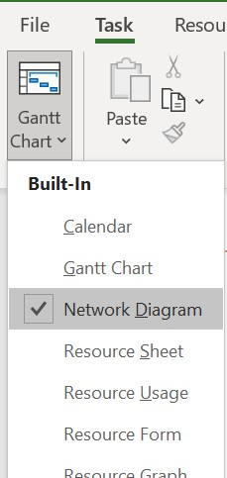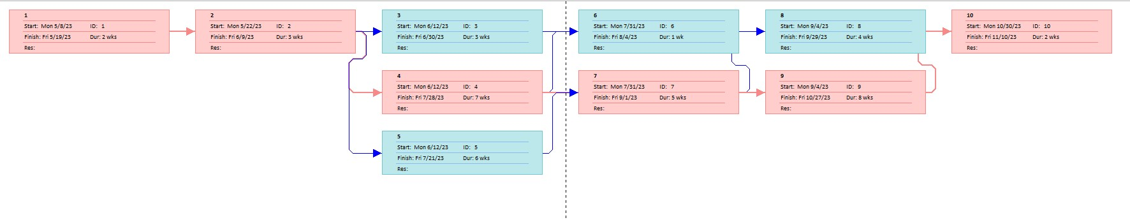

**Select**

Here, the pink shades represent critical path. Hence, the critical path is 1-2-4-7-9-10.

**Numerical 2:**

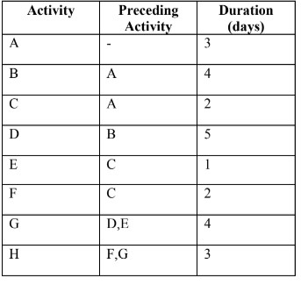

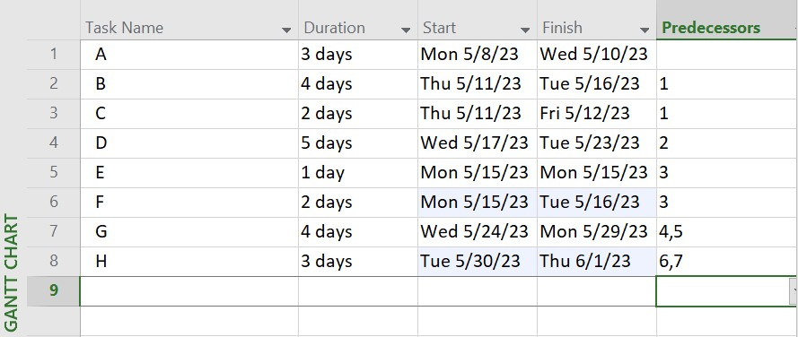

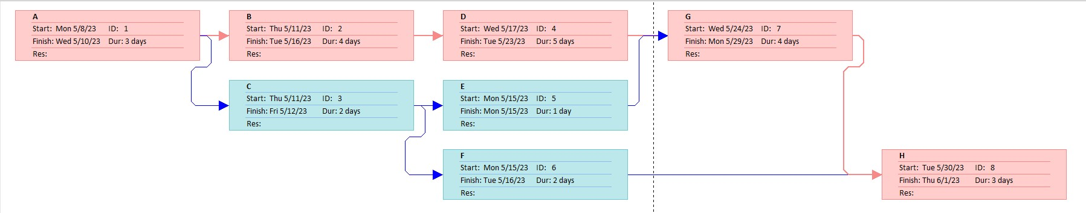

Hence, the critical path is A-B-D-G-H.

# Lab 10: Git and GitHub

Git is a distributed version control system that allows developers to track changes in their codebase, collaborate with others, and manage different versions of their projects.

GitHub is a web-based hosting service for Git repositories and provides additional collaboration and project management features.

1. git status

It is used to display the current state of the Git repository. It is useful to quickly check the status of your repository, see what changes have been made, and determine which file is ready to be commited or needed to be added.

2. git init

Before doing anything on git, we first have to create a repository and git init allows us to do so.



'git init' has created a local repository on our PC in this case. Now, git init provides information about the files that are present in our repositories.

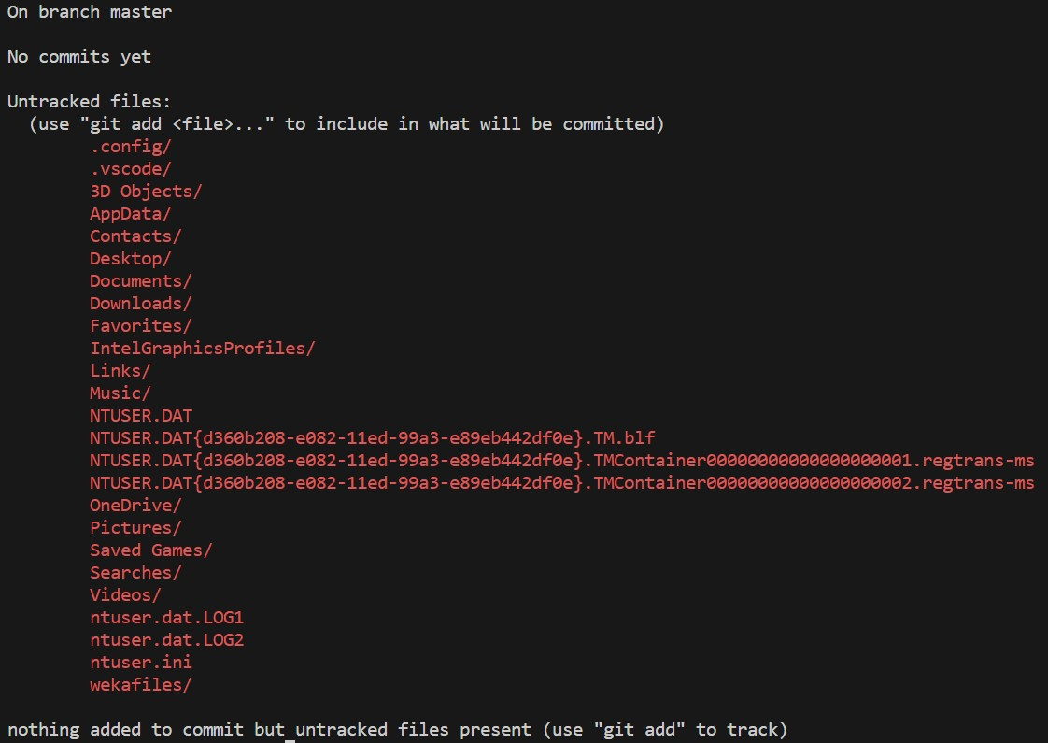

3. git remote add origin <…>

We must construct a remote origin or remote repository to keep the files from the local repository in order to upload the project or files to github. We sign up and log in to github.com to do this. After logging in, we select “New repository” from the drop-down box by clicking the "+" symbol next to profile.

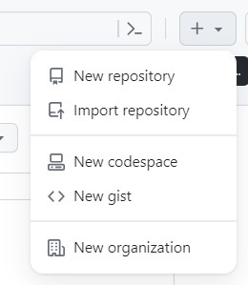

This opens up a form asking for details regarding the new repository like the following:

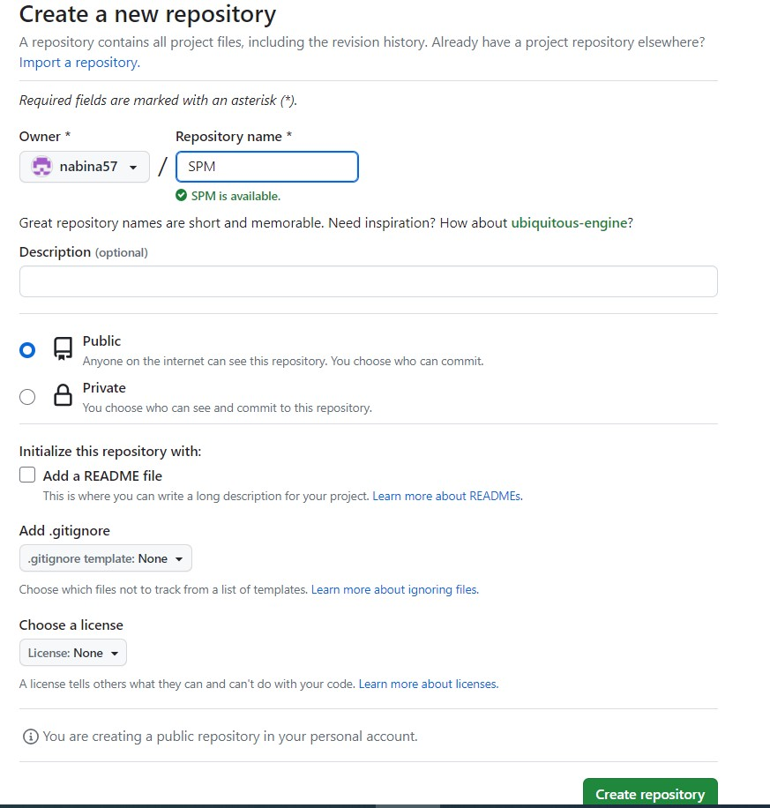

It is advised to include the project name in the 'Repository name' field for simplicity and effectiveness. Click the "Create repository" button after filling out the form, and our remote repository will be ready.

Now, we add the local repository to the remote repository using git remote add origin <…>.



Here, ‘origin’ is the name of the remote repository and <https://github.com/nabina57/SPM.git>is the link to the repository.

4. git remote

We use git remote, to check the available or connected remote repositories.



Here, we can see we are connected to a remote repository named ‘origin.’

5. git add <…>

We have created both local and remote repository but our repository is still empty. To add files to be tracked to our repository, we first use git add to get them ready or staged.

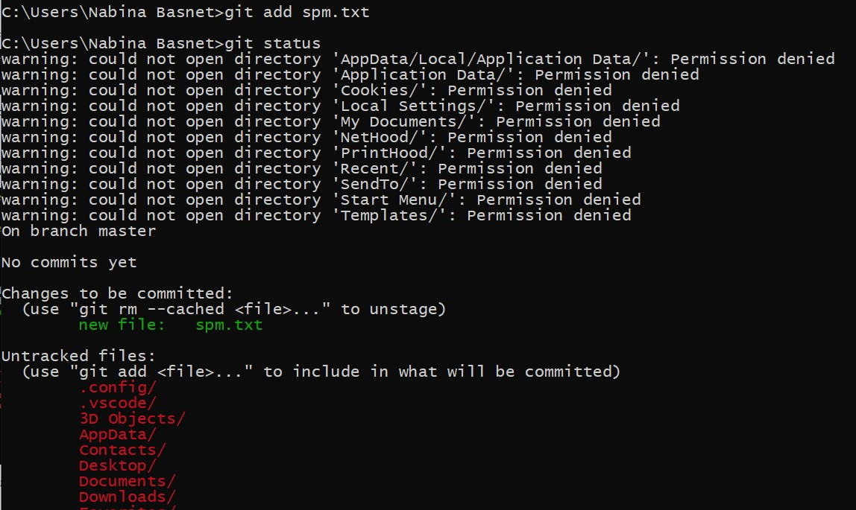

We have now added or staged the file ‘spm.txt’ for the repository. The results can be seen after using git status. However, the file is still not tracked or present on the repository.

6. git commit

After the finished and prepared versions of the files or updates are added to the primary source or remote repository. Utilizing git commit, they are committed. The files have now been posted to the repository, so to speak. Still, it is only available through the local repository.

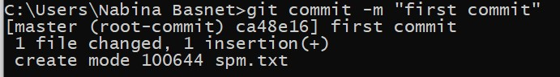

Here, -m is an argument used to pass message related to the changes we are saving or committing. This this case the message or remarks is “commit.”

7. git push -u origin <…>

Whenever we want to upload the changes or files to the main source or remote repository on github, we use git push.

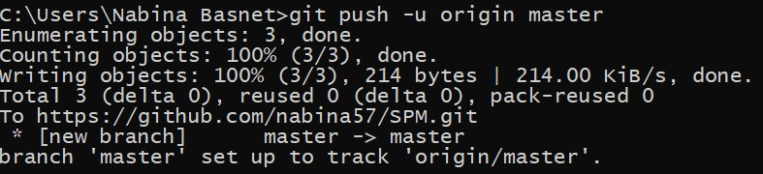

Here, ‘origin’ is the name of the remote repository and ‘master’ is the name of local repository. Hence, the command **git push –u origin master** means pushing the files and changes to the repository named ‘origin’ from the local repository named ‘master’.

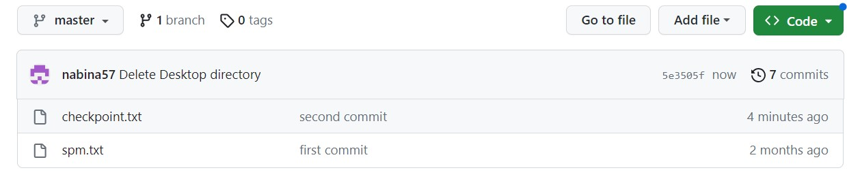

8. git reset

When we add or stage files and later decide to remove them, we can use git reset to undo the staging. It is shown as follows:

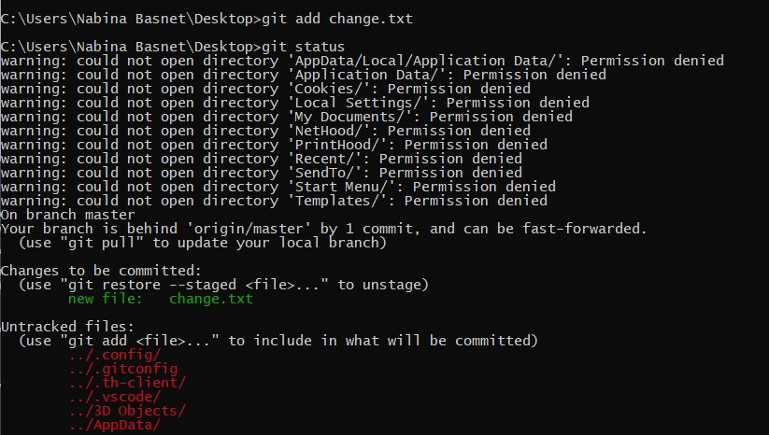

We added ‘change.txt’ but now we do not want to commit it so we use git reset to unstage the changes file.

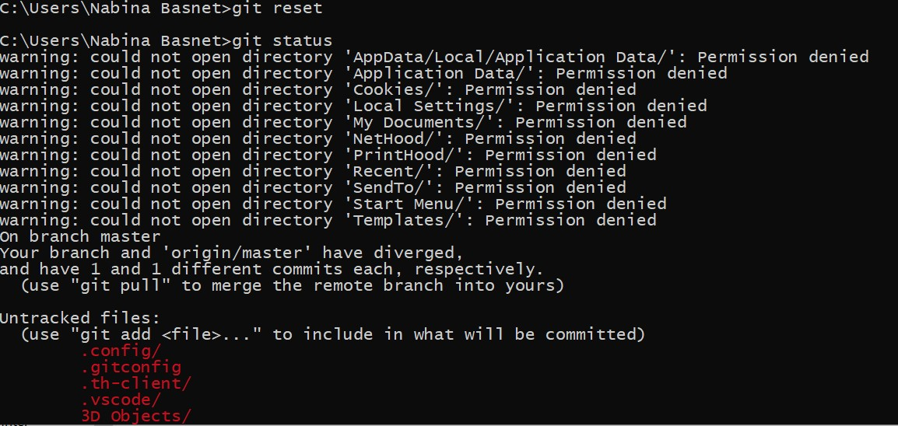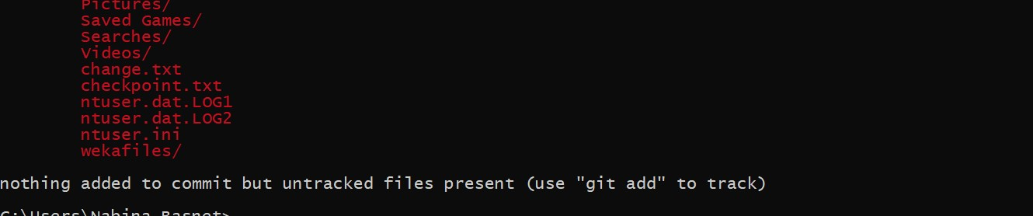

9. git fetch

We are not always alerted when changes are made in the source or remote repository. To see if the repository has undergone any modifications, we use get fetch. We started by adding a file to the remote repository for this.

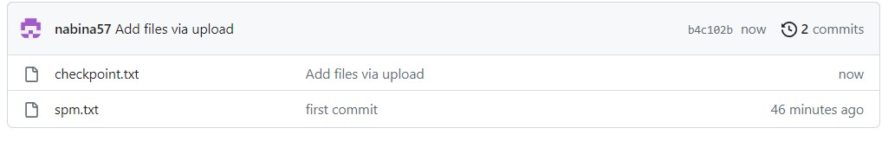

After adding a file to the remote repository, we checked status from local repository.

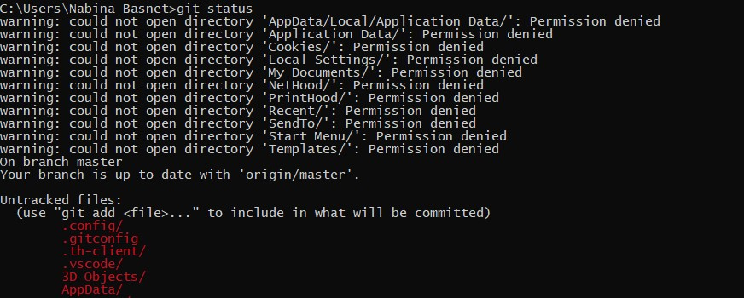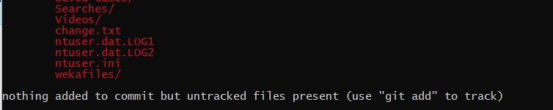

Despite the fact that adjustments have already been made, none are visible to us here. We now utilize git fetch to retrieve data from the remote repository and once more use git status.

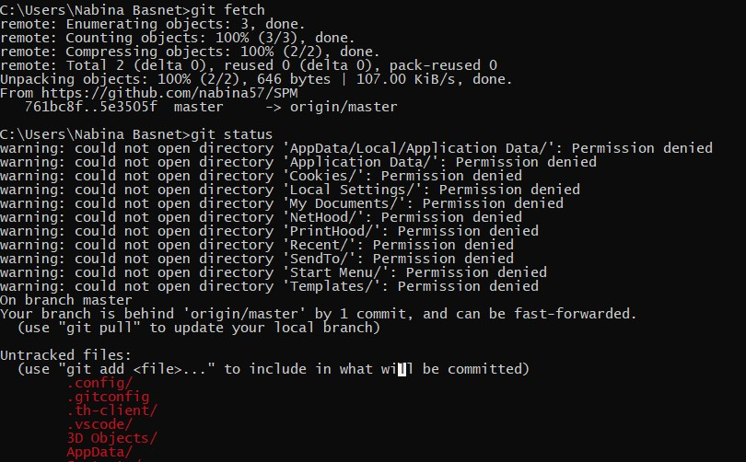

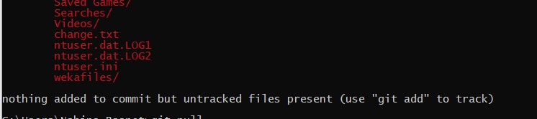

After running fetch, we can observe that the source or remote repository is one commit ahead of our local repository. The modifications haven't been added to the local repository; this is merely a notice.

10. git pull

To bring changes into our local repository we use, git pull. It brings all the commits as well as downloads the files that are present only on the source or remote repository.

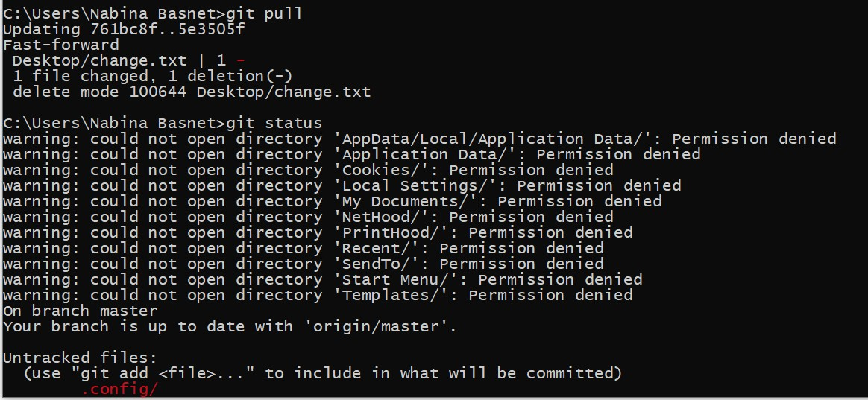

As we can see git pull has added one commit and changed 1 file. Moreover, it has also created a new file named ‘change.txt’ on the local directory or repository. When we run git status after git pull, we can see both local and remote repository are updated and synchronized.